File # TVIP00390532 | Pt. Name - SAEED YOUSEF HUSAIN | Dr. ALTAYEB
NEW PATIENT
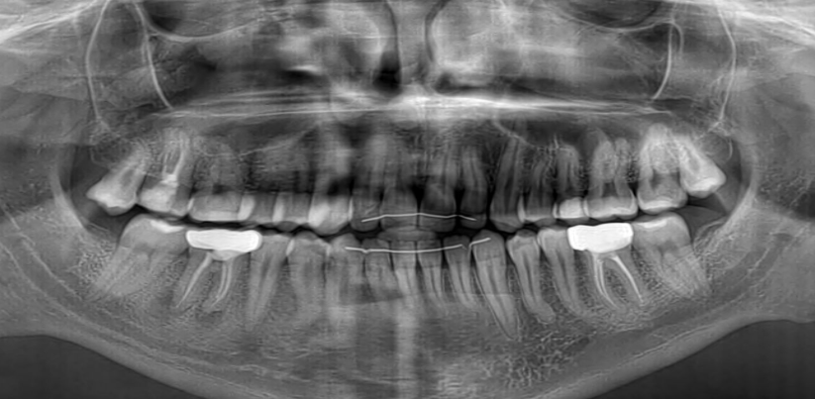

File # TVIP01014351 | Pt. Name - ALY IBRAHIM MOHAMED | Dr. FATIMA
NEW PATIENT
NO OPG

File # TVIP00372455 | Pt. Name - MAITHA ABDULLA MOHAMMAD | Dr. Basil
LAST VISIT SEPT. 03, 2025
NO OPG

File # TVIP00398065 | Pt. Name - Wadha Khalifa Mohammed | Dr. Basil
LAST VISIT OCT. 04, 2025
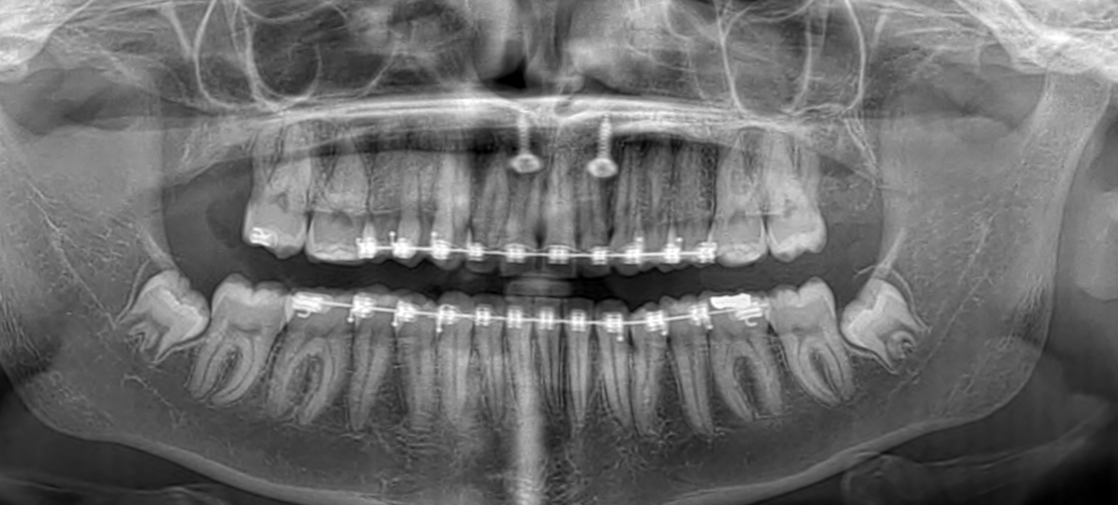

File # TVIP00387044 | Pt. Name - QASAYED JASEM SAIF | Dr. Basil
LAST VISIT JULY. 08, 2025

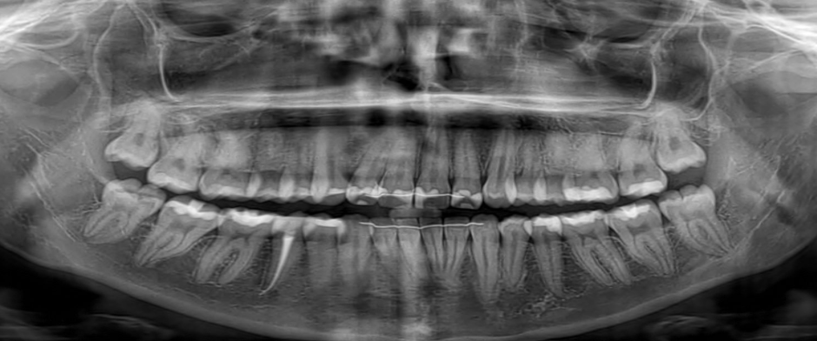

File # TVIP00365229 | Pt. Name - Hind Mohammed Saeed | Dr. Basil
LAST VISIT SEPT. 01, 2025
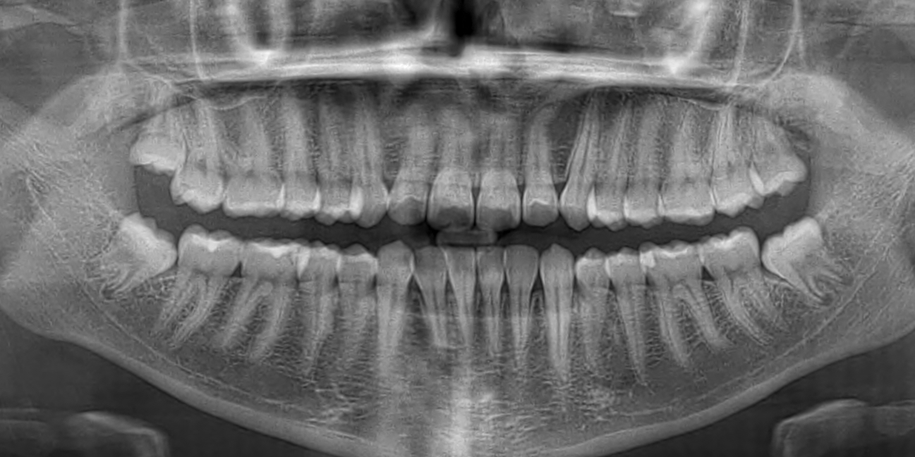

File # TVIP00386704 | Pt. Name - OBAID HELAL OBAID | Dr. Basil
LAST VISIT OCT. 08, 2025
